**DAILY ONLINE ACTIVITIES SUMMARY**

|  |  |  |  |  |  |  |  |  |
| --- | --- | --- | --- | --- | --- | --- | --- | --- |
| **Date:** | **10-6-2020** | | | | | **Name:** | **Prajna** | |
| **Sem & Sec** | **8th sem ‘B’** | | | | | **USN:** | **4AL16CS067** | |
| **Online Test Summary** | | | | | | | | |
| **Subject** | | **-** | | | | | | |
| **Max. Marks** | | **-** | | **Score** | | | **-** | |
| **Certification Course Summary** | | | | | | | | |
| **Course** | **Introduction to ethical hacking** | | | | | | | |
| **Certificate Provider** | | | **Great Learning** | | **Duration** | | | **4hrs** |
| **Coding Challenges** | | | | | | | | |
| **Problem Statement:**1**.** Write a java program to display the prime numbers between the given range. | | | | | | | | |
| **Status: Completed** | | | | | | | | |
| **Uploaded the report in GitHub**  **GitHub link:** | | | | | **Yes**  **https://github.com/alvas-education-foundation/prajna_k** | | | |
| **If yes Repository name** | | | | | **prajna_k** | | | |
| **Uploaded the report in slack** | | | | | **yes** | | | |

Online Test Details: (Attach the snapshot and briefly write the report for the same)

Certification Course Details: (Attach the snapshot and briefly write the report for the same)

Coding Challenges Details: (Attach the snapshot and briefly write the report for the same)

2) certification course

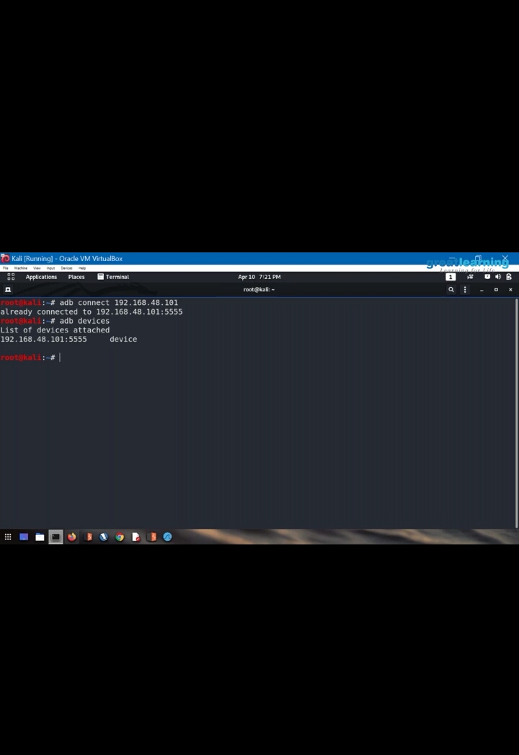

3) coding challenges

Program 1

import java.util.Scanner;

public class PrimeBetweenRange

{

public static void main(String args[])

{

int s1, s2,count = 0, i, j;

Scanner s = new Scanner(System.in);

System.out.print("Enter the lower limit : ");

s1 = s.nextInt();

System.out.print("Enter the upper limit :");

s2 = s.nextInt();

System.out.println("Prime numbers between given range are :");

for(i = s1; i <= s2; i++)

{

for( j = 2; j < i; j++)

{

if(i % j == 0)

{

count = 0;

break;

}

else

{

count = 1;

}

}

if(count == 1)

{

System.out.println(i);

}

}

}

}

|  |
| --- |
|  |
|  |  |
|  |  |
|  |  |
|  |  |
|  |  |